Are you interested In Any of The Following Course (Only at $11)

* **Scala Programming- A Well Known Programming Language used in Big Data Field (3+ Hours - 3000 students)**

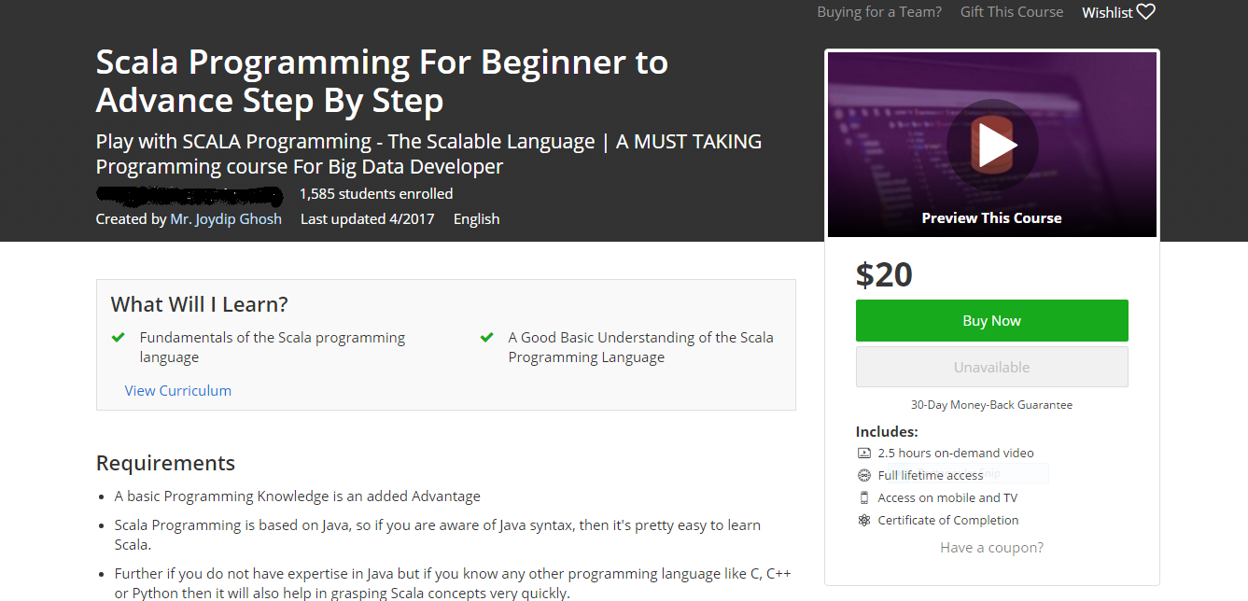​

* **Topics Covered:**
* **Literals, Values, Variables, and Types**
* **String Interpolation**
* **If Else Statement and Expression**
* **Match Expressions**
* **Loops – for and while**
* **Pattern Matching**
* **Functions**
* **Recursive Functions**
* **Nested Functions**
* **Calling Functions with Named Parameters**
* **Parameters with Default Values**
* **VarArg Parameters**
* **Parameter Groups**
* **Methods and Operators**
* **Higher-Order Functions**
* **Partially Applied Functions and Currying**
* **Collections – List, Sets and Maps**
* **Array, Seq, Stream, Tuples**

[**CLICK HERE TO ENROLL**](https://www.udemy.com/scala_scalable_functional_programming_language_kids_beginners_scratch/?couponCode=ANNOU_PROMO)**​**

* **Ethical Hacking (12+ Hours Course - 4.3 Feedback - 15,000+ Students)**

​

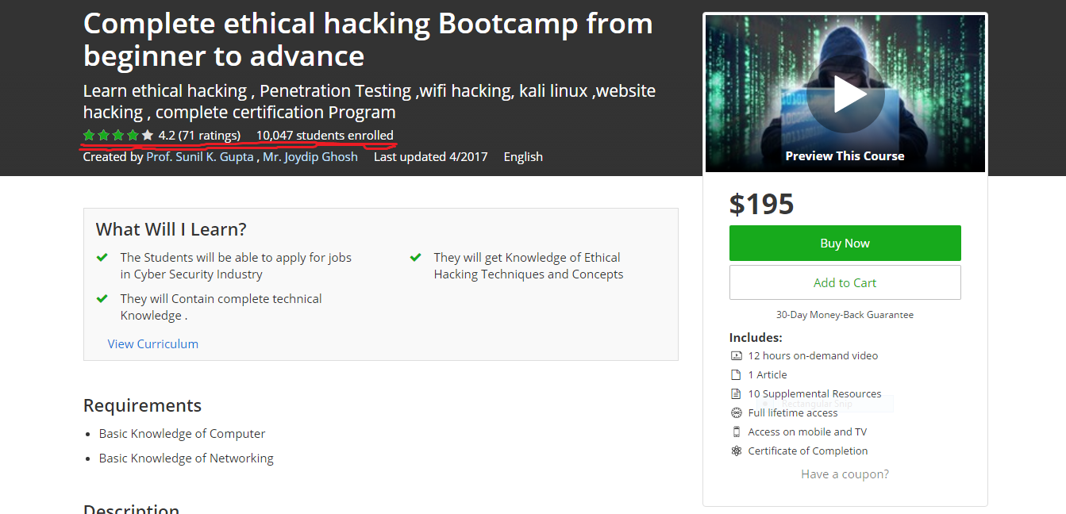​

* **Topics Covers:**
* **System Hackinng**
* **Ethical Hacking**
* **White Hat Hacking**
* **Penetration Testing**
* **Website Hacking**
* **Facebook Hacking**
* **WiFi Hacking**
* **Kali Linux**
* **Virtual Box etc**

[**ENROLL IN THE COURSE NOW at $11**](https://www.udemy.com/complete-ethical-hacking-course-2017-exploring-secrets/?couponCode=COUPON20)**​​**

​

* **Python Programming Boot camp (5+ Hours – 5000+ Students)**

​  
  
Topics Covered:

* **Python setup**
* **Python IDE**
* **Variables**
* **Python Operators**
* **Arithemetic Operator**
* **Comparison Operator**
* **Assignment Operator**
* **Bitwise Operator**
* **Membership Operator**
* **Identity Operator**
* **If Statement**
* **If Else Statement**
* **Break & Continue Statement**
* **For Loop**
* **While Loop**
* **Home Assignment**
* **String**
* **Number**
* **List**
* **Dictionary**
* **Function**
* **Module**
* **Exception**
* **Home Assignment​​​​​​​​​​​​​​​​​​​ ​**
* **File Operation**
* **File Reading**
* **File Writing**
* **Appending File**

[**ENROLL ONLY FOR $11 TODAY ONLY**](https://www.udemy.com/python-django-programming-beginner-to-advance-tutorial-step-by-step/?couponCode=PROMOMARCH)**​**

**​**

* **Ebay Dropshipping- Work From home (2+ Hours - 14,000 Students - 4.3 Feedback**

**​ Rating)**

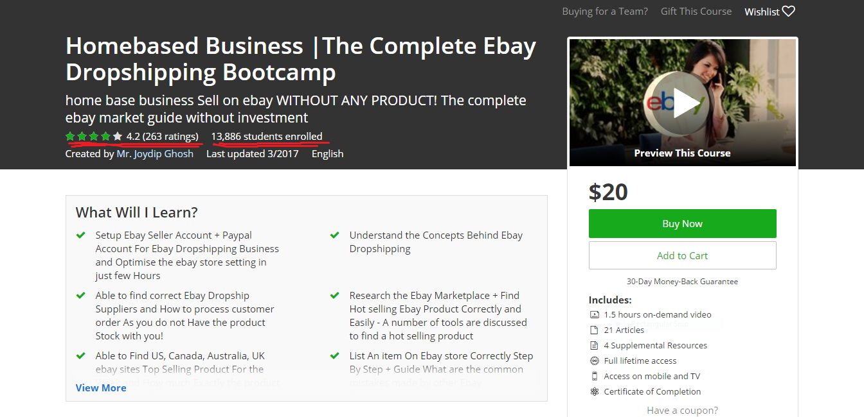​

* **Topics Covered:**
* **Ebay Account Setup**
* **Find Profitable Products**
* **Research Tool to increase sell**
* **Title optimization for Ebay SEO**
* **List Live Products**
* **Order Handling**
* **Processing Order**
* **Handle Return**

[**ENROLL IN THE COURSE**](https://www.udemy.com/top-ebay-dropshiping-course/?couponCode=PROMOMARCH)**​**